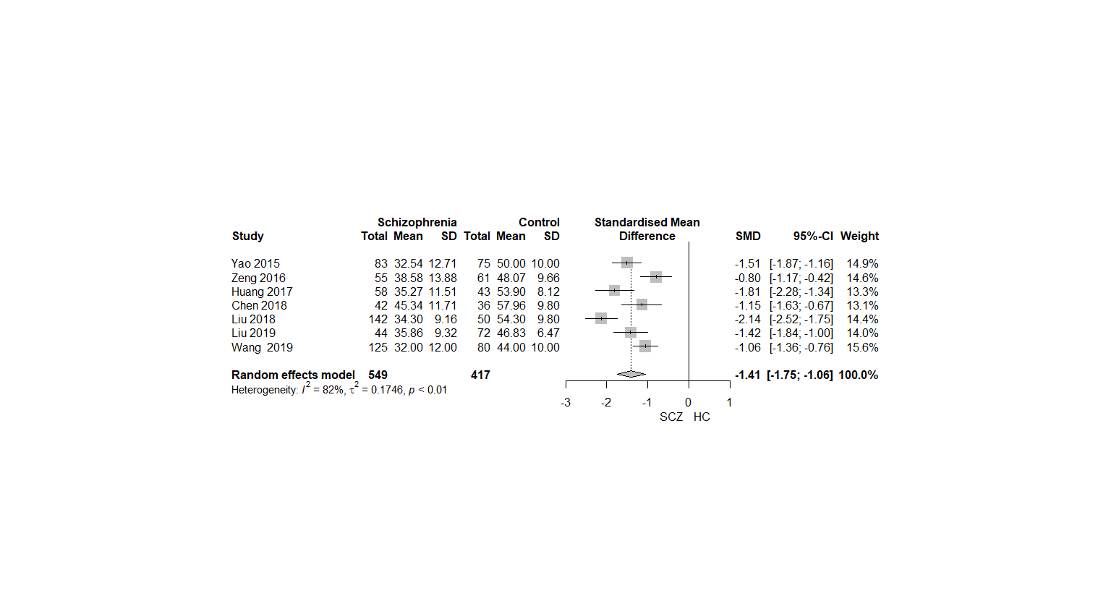
Fig.A.1 Speed of processing score comparison between patients with FES and HCs

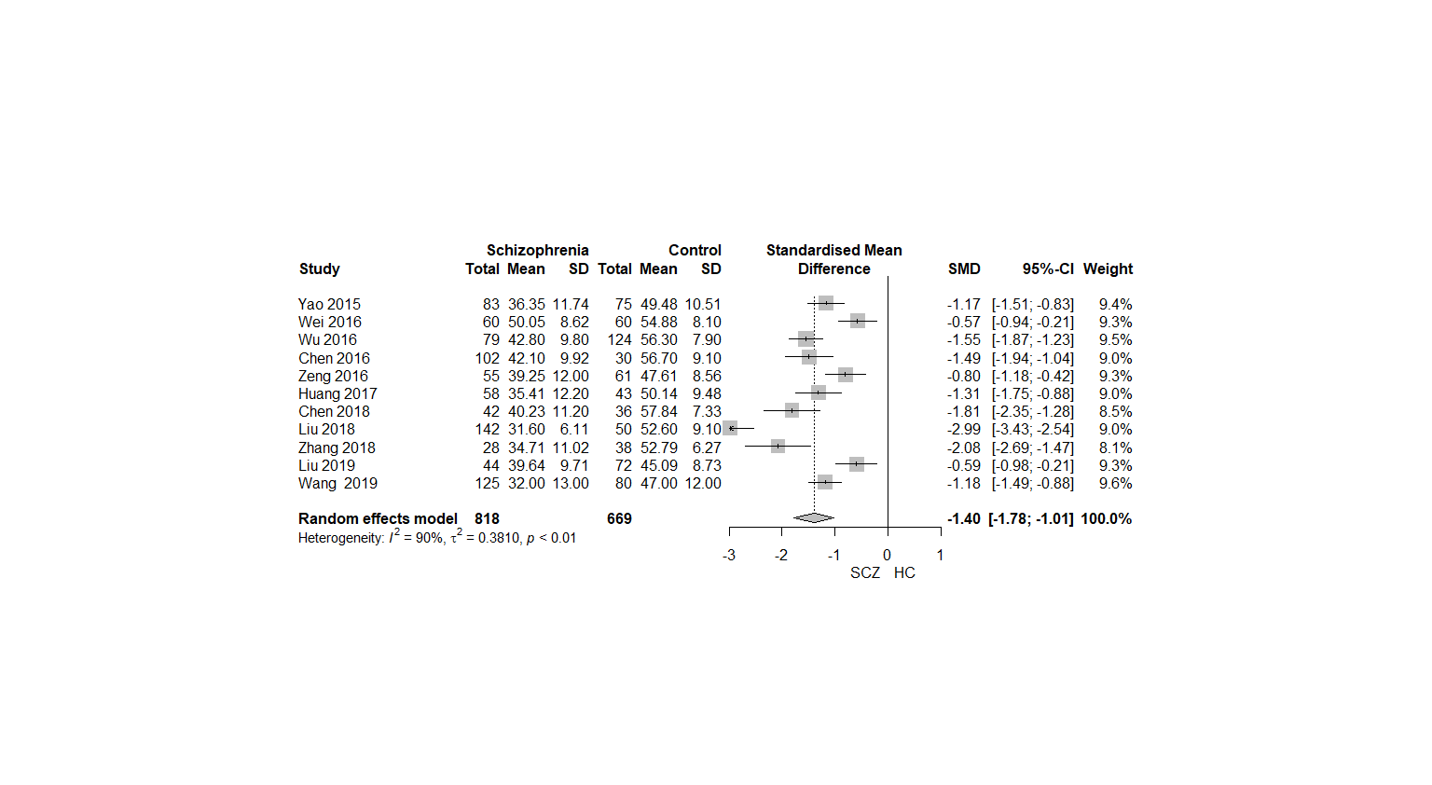
Fig.A.2 Attention and vigilance score comparison between patients with FES and HCs
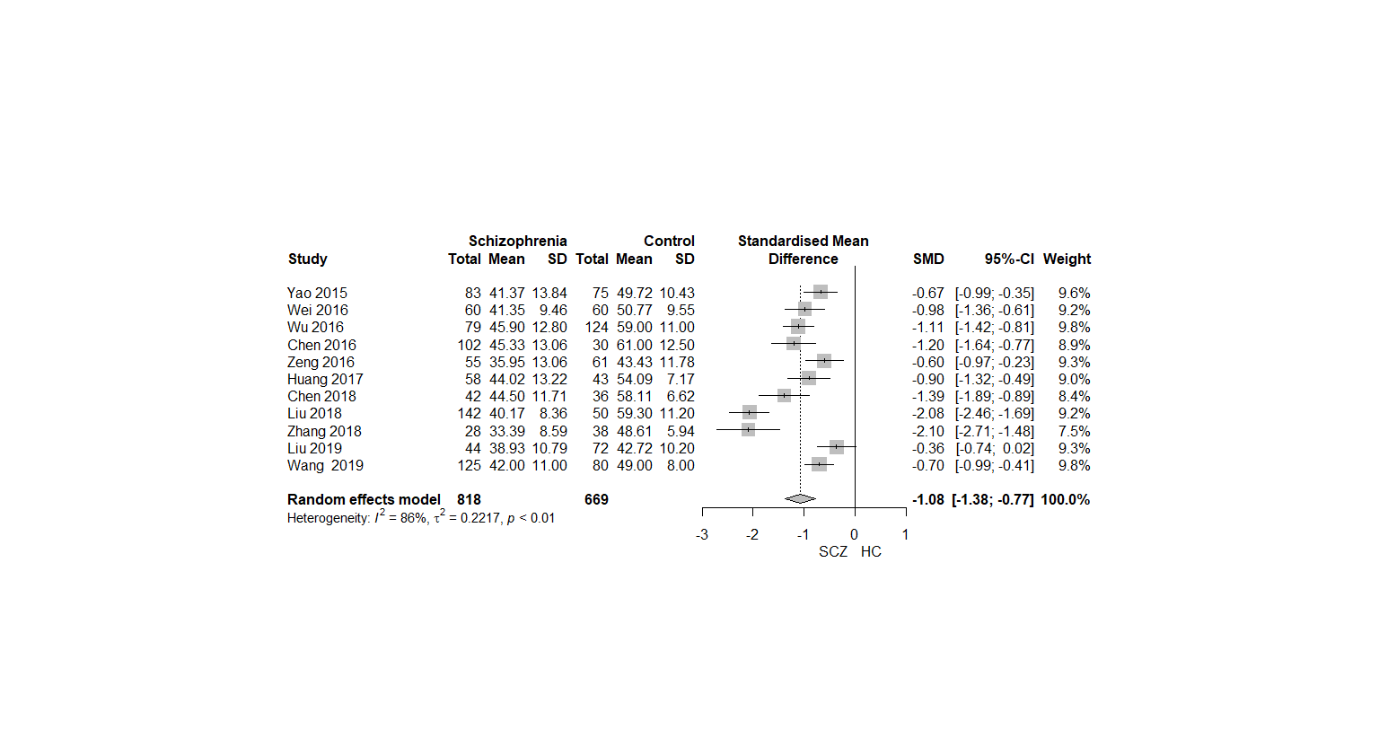
Fig.A.3 Working memory domain comparison between patients with FES and HCs
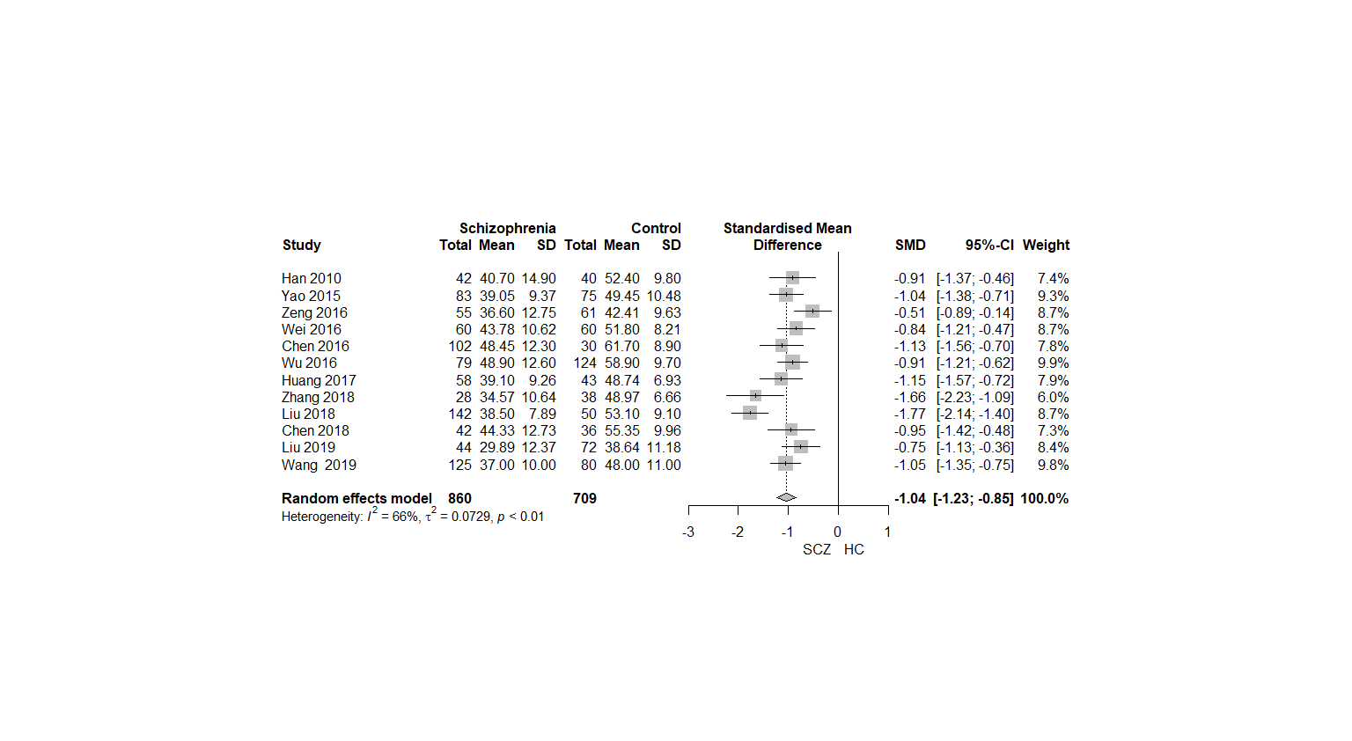
Fig.A.4 Verbal learning domain score comparison between patients with FES and HC
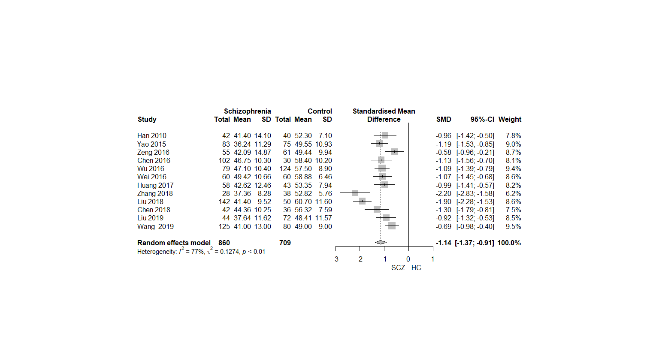
Fig.A.5 Visual learning domain score comparison between patients with FES and HC
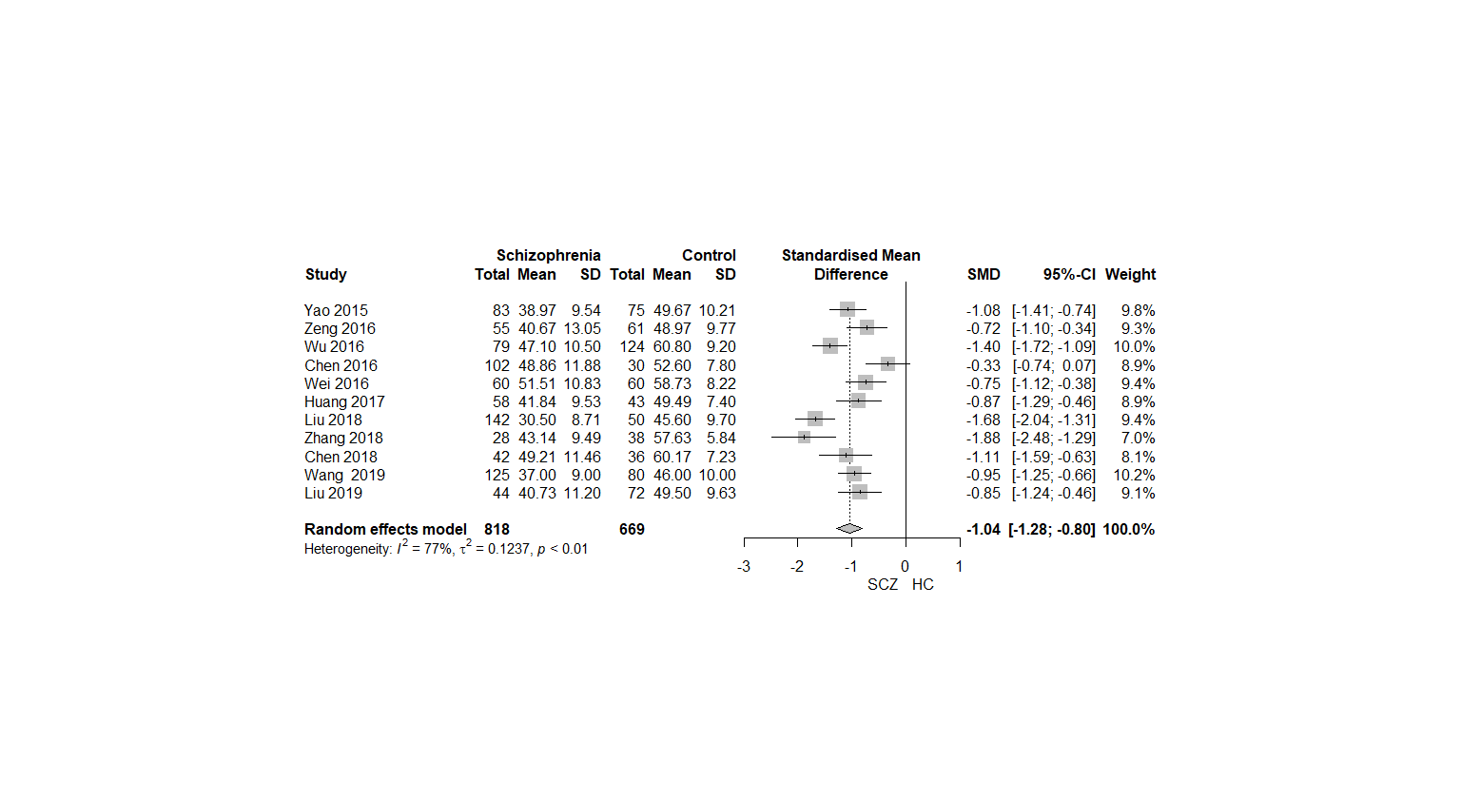
Fig.A.6 Problem solving domain score comparison between patients with FES and HCs
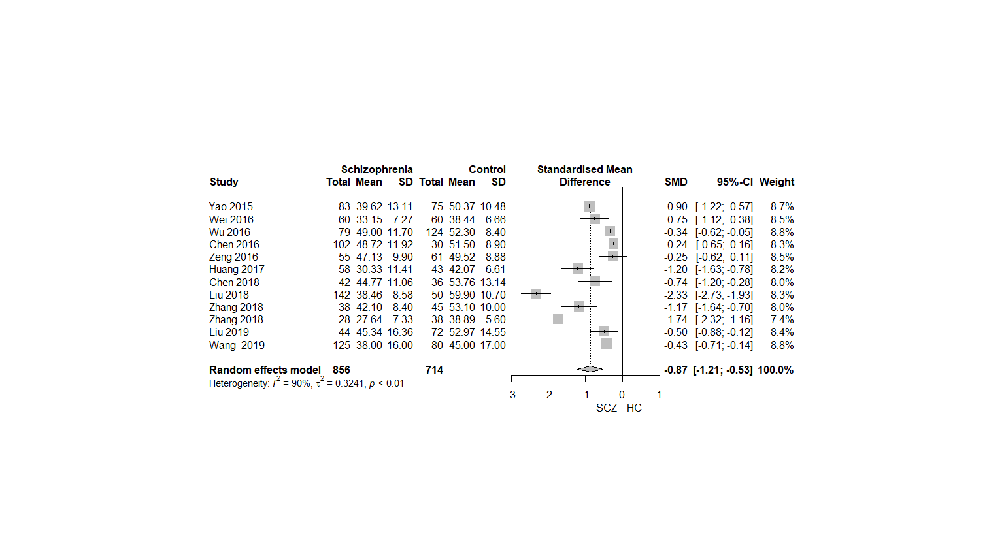
Fig.A.7 Social cognition domain score comparison between patients with FES and HCs
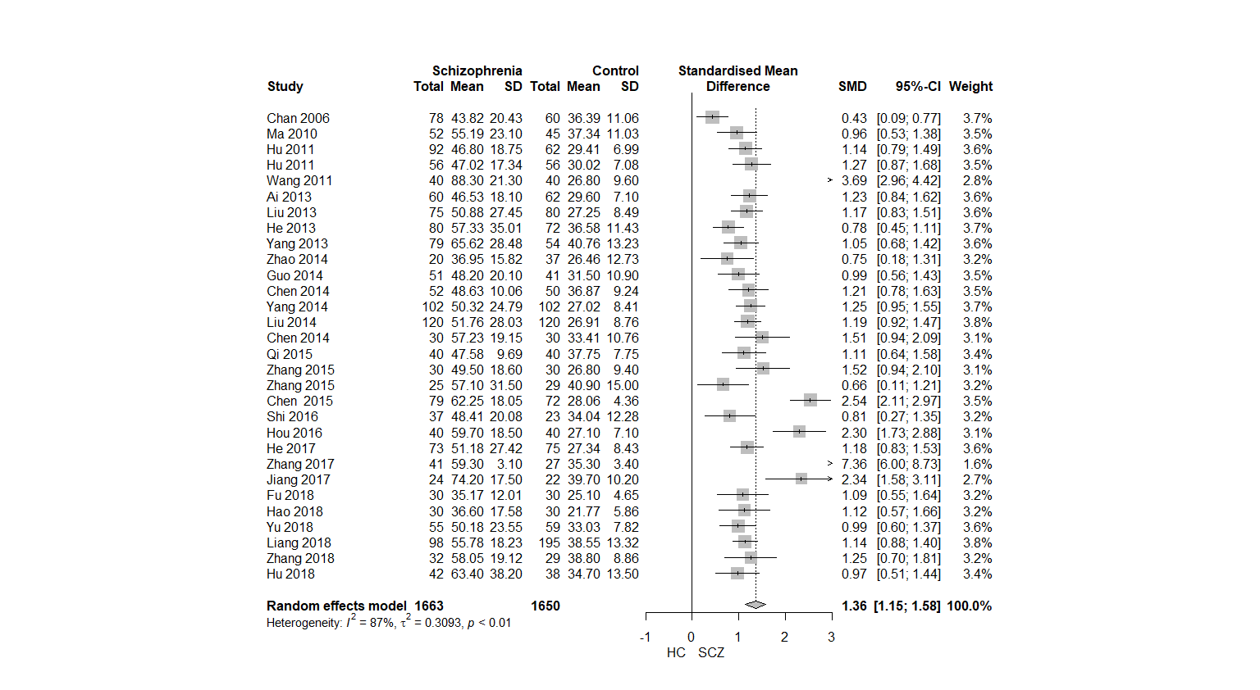
Fig.A.8 Trail making test score (completion time) comparison between patients with FES and HCs
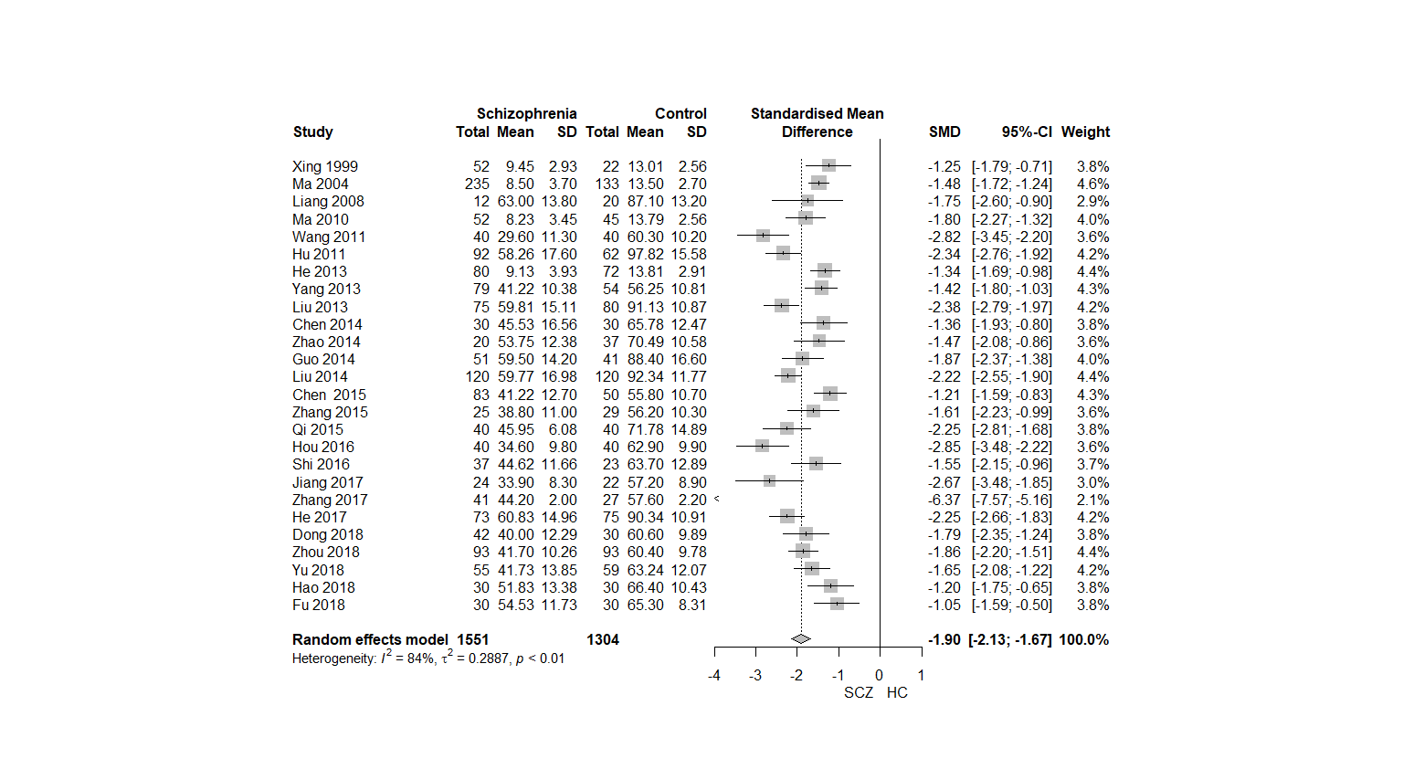
Fig.A.9 Symbol Coding test score comparison between patients with FES and HCs
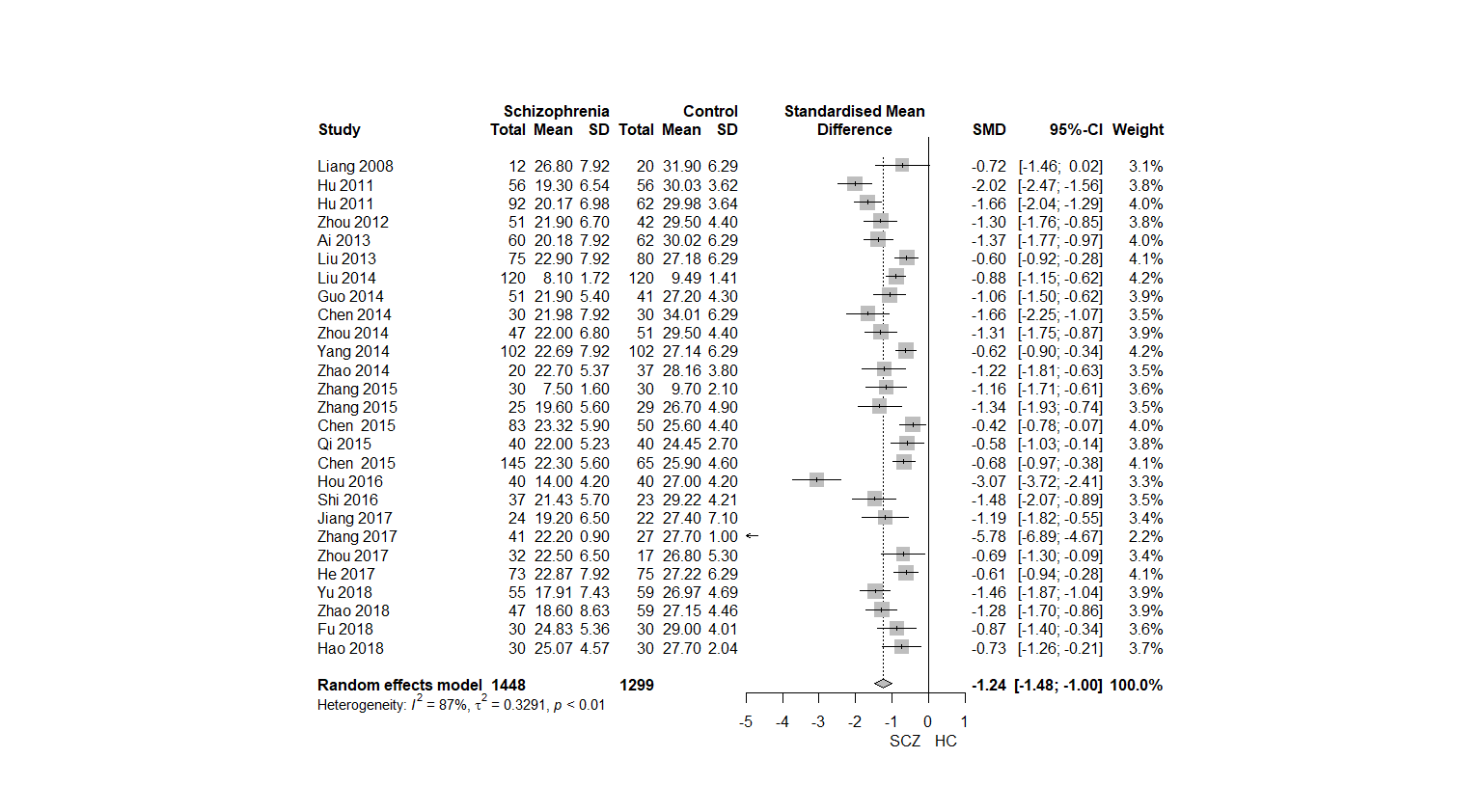
Fig.A.10 HVLT-R score comparison between patients with FES and HCs

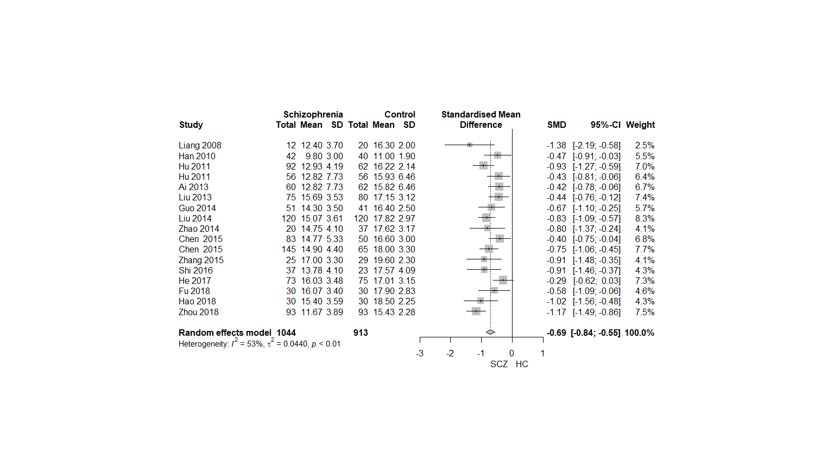
Fig.A.11 Spatial span score comparison between patients with FES and HCs
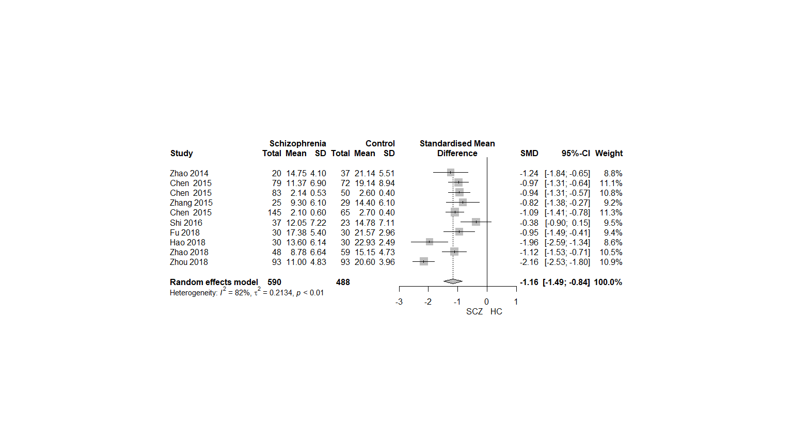
Fig.A.12 Mazes score comparison between patients with FES and HCs
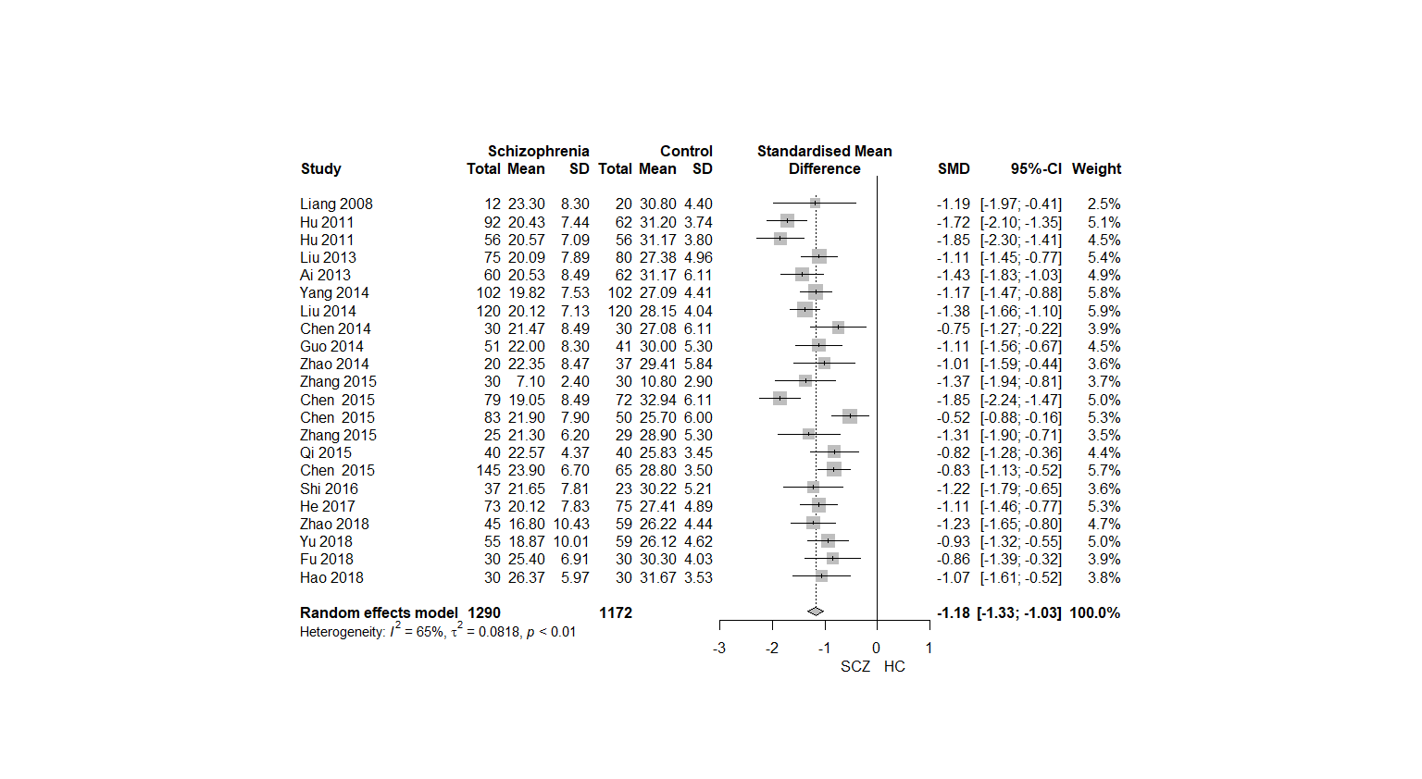
Fig.A.13 BVMT score comparison between patients with FES and HCs
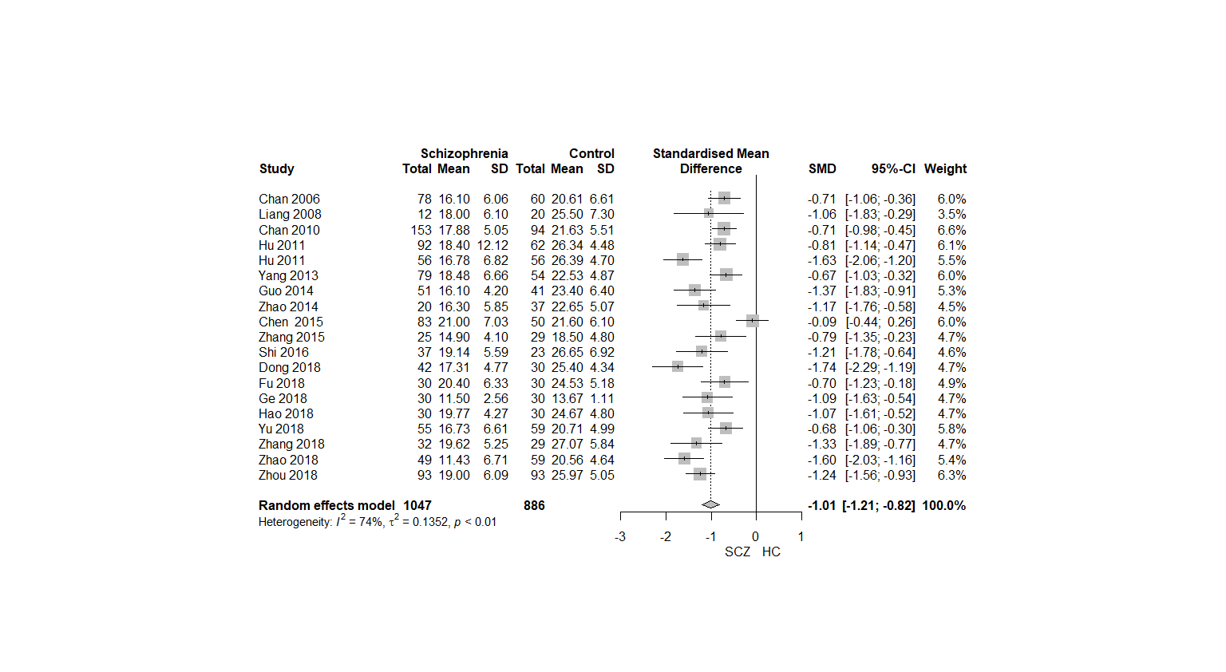
Fig.A.14 Category fluency score comparison between patients with FES and HCs
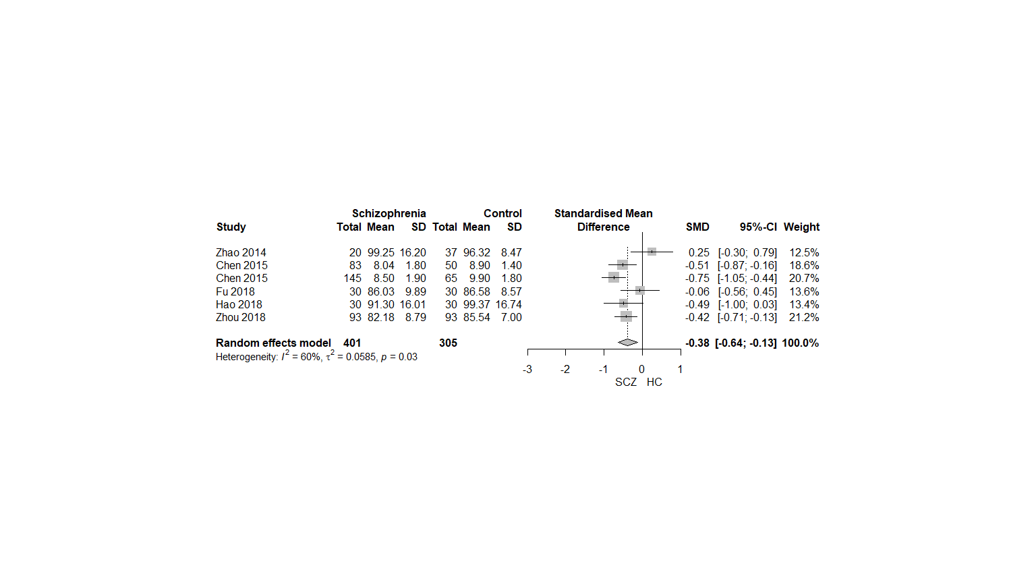
Fig.A.15 MSCEIT test score comparison between patients with FES and HCs
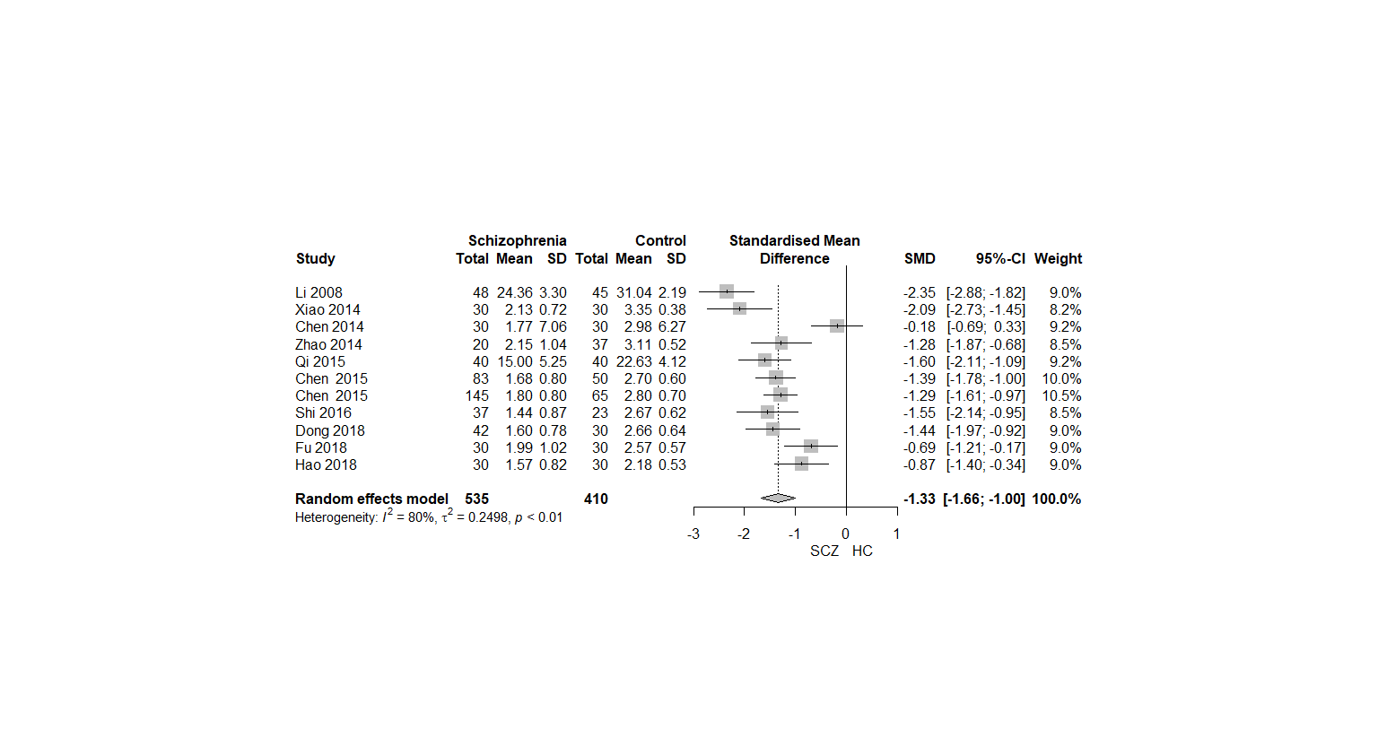
Fig.A.16 CPT-IP score comparison between patients with FES and HCs

